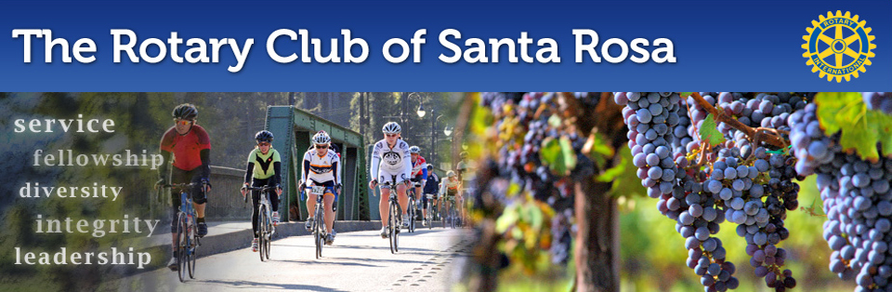
Rotary Club of Santa Rosa
and the Rotary Club of Santa Rosa Foundation
COMMUNITY GRANTS PROGRAM
Deadline: October 31, 2016

Dear Prospective Applicant:

The Rotary Club of Santa Rosa and the Rotary Club of Santa Rosa Foundation are pleased to announce the opening of their 2016-2017 community grants program, and invite you to consider submitting a grant application.

Grant guidelines, limitations and requirements are detailed in the application process below. The application deadline is October 31, 2016, and funds will be distributed for approved grants in December 2016.

Organizations eligible to apply for grants are limited to qualified IRS 501(c)(3)
non-profits or public schools. Grants are available in the range of $1,000 to $10,000.

Questions about the grant application process should be directed to either Co-Chair of the Rotary Joint Charitable Projects Committee:

- Cathy Vicini - cathy@trecini.com or
- Marnie Goldschlag at marnie@marnie4homes.com

The Rotary Club of Santa Rosa is proud of its service to the local community over the past 90 years, and encourages you and your organization to consider applying for a community grant this year.

Sincerely,

José O. Guillén, President Norm Owen, President
Rotary Club of Santa Rosa Rotary Club of Santa Rosa Foundation

Rotary Club of Santa Rosa
and the Rotary Club of Santa Rosa Foundation
Community Grant Guidelines & RequireMents

The Rotary Club of Santa Rosa and the Rotary Club of Santa Rosa Foundation are dedicated to serving the greater Santa Rosa area through a community grants program aimed at supporting local projects & activities that benefit the community and improve the area’s quality of life.

Guidelines & Requirements:

1. All applicants MUST be a qualified IRS 501(c)(3) non-profit or a public school.

2. Projects must involve one or more of the following areas of interest:
- Help for the Less Fortunate
- Children & Youth
- Quality of Life
- Education for All Ages
- Arts & Culture
- Battered & Abused People

3. Grants will NOT be approved for the following:
- Administrative Salaries or Annual Operating Expenses
- Projects Supported by Parents for Benefit of Their Own Children
- Projects for a Religious or Political Purpose
- Individuals
- Projects of a Controversial Nature

4. Grant applications will be considered in the range of $1,000 to $10,000.

5. Grants are limited to ONE application per organization per 12-month period.

6. Applicants must use the Community Grant Application form. Incomplete applications will NOT be considered for funding.

7. All applications must be received by no later than October 31 2016.

8. Grant recipients are required to submit a written report on project outcomes within 60 days of project completion. Project photos are appreciated, if applicable.

If you have any questions, please contact Co-Chair of the Rotary Joint Charitable Projects Committee:
Cathy Vicini at cathy@trecini.com
Marnie Goldschlag at marnie@marnie4homes.com

Applications must be submitted via email (preferred) or regular mail to:
Charitable Projects Committee
Rotary Club of Santa Rosa
debizaft@sonic.net
cc: cathy@trecini.com
PO Box 505
Santa Rosa, CA 95402

ORGANIZATIONAL INFORMATION:

Contact Information:
Name of Organization or School:
Street Mailing Address:
City, State & Zip code:
Website Address:

Contact People:
Name of CEO or Principal:
CEO/Principal’s Telephone:
CEO/Principal’s Email:
Name & Title of Grant Contact: (If Different)
Grant Contact’s Telephone:
Grant Contact’s Email:

List Current Members of Your Board of Directors:

Application Category:
☐ Public School
☐ 501(c)(3) Non-Profit Organization (Provide Tax ID # 94-1156528:

Organization’s Mission:

Organization’s Annual Operating Budget:

Organization's Primary Funding Sources:
Public Grants: | $_________________
Private Grants: | $_________________
Fundraisers: | $_________________
Corporate Sponsors: | $_________________
Individual Donations: | $_________________
Sales, Services or Fees: | $_________________
Other:  TOTAL; | $_________________  $_________________

Tell Us More about Your Organization:
For example: How long has your organization been in existence? Describe other successful projects you have sponsored. Tell us those accomplishments about which you are most proud, including any honors or awards the organization has received.

PROJECT INFORMATION:

Project Name:

Rotary Grant Amount Requested:

Project Description and Timeline:

Project Area(s) of Focus:
☐ Help for the Less Fortunate ☐ Education for All Ages
☐ Children & Youth ☐ Arts & Culture
☐ Quality of Life ☐ Battered & Abused People

Describe Who Will Benefit from This Project and Where in Sonoma County They Are Located:

How Will the Project’s Effectiveness Be Evaluated (Qualitative & Quantitative)?

Project Budget Expenses: Administrative Program  Salaries & Benefits $ $  Equipment & Supplies $ $  Rent/Lease/Mortgage $ $  Travel/Lodging/Training $ $  $ $  $ $  Project Total: $ $ |  | p
How Will the Requested Rotary Funds Be Used?
Administrative $
Program $
Please provide the following information regarding other matching funds for this project:

- If your organization has received or is receiving other grants or funding for this project, please tell us who, when, and how much was/is the grant amount?

- If your organization is currently requesting grant funds from other organizations, please tell us the name(s) of the organization(s) and how much is being requested?

- If your project is not fully funded by this requested grant, what are your plans to secure sufficient funding to complete this project?

- If funding is needed to sustain project beyond initial grant funds, what are your plans for maintaining or sustaining this project?

Any Other Pertinent Comments Not Covered Above?

How Will Rotary’s Contribution Be Recognized? (Check All That Apply):
☐ Brochure ☐ Signage
☐ Mailing ☐ Website
☐ Newsletter ☐ Other:
Please explain:

Describe Any Potential Opportunities for Rotary Members to Participate in This Project:

